**User testing report**

This report is based on the assignment 2 of web design, and the purpose of this report is to test the website that student made. **The feedback from user had been organized in order to made a proper report**.

**User information**:

**Name:** Zhiqiang Zhu

**Phone:** +86-1382566xxxx

**Age:** 53

**Employment:** Manager of Human Resources

**Special Interests:** love eating sweet food and swimming

**User notes:**

The feedback was being written when the user was speaking, so the answer was being written with simplify format.

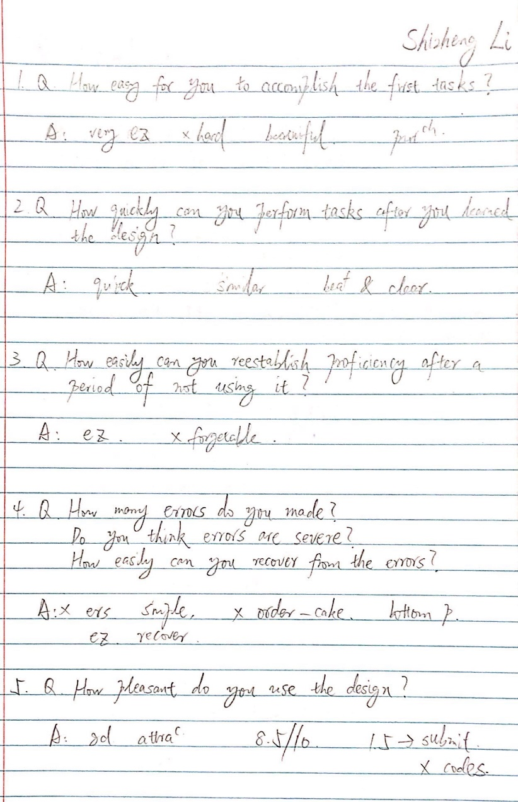

• **Learnability:** How easy is it for users to accomplish basic tasks the first time they encounter the design?

Could you tell me how easy for you to accomplish the first tasks?

Feedback from user: It was easy for me to reach the task you asked me to do last time, the website was basically the real website, and the design looked beautiful. If it is the real website for selling cakes, I would like to purchase it.

My report: It was easy for the user to accomplish the basic task, but there was a small error which is the submit button was missing.

• **Efficiency:** Once users have learned the design, how quickly can they perform tasks?

How quickly can you perform tasks after you learned the design?

Feedback from user: It was very quick for me to perform the task if I am similar with it. Your website is beautiful and clear.

My report: The user can perform the task quickly after I told him about my design.

• **Memorability:** When users return to the design after a period of not using it, how easily can they reestablish proficiency?

How easily can you reestablish proficiency after a period of not using it?

Feedback from user: It was still easy for me to reestablish proficiency, I was not forgettable.

My report: The user was still able to reestablish proficiency easily.

• **Errors:** How many errors do users make, how severe are these errors, and how easily can they recover from the errors?

How many errors do you made?

Do you think these errors are severe?

How easily can you recover from the errors?

Feedback from user: I basically did not make any errors, the website is simple, not complicated. By the way, is it can be recognized as an error if I cannot find how to order the product in the cake page? I found the order function at the bottom of the page immediately, so it was just a tiny slight error. It is pretty easy to recover.

My report: The user did not make a typical error, he found out the order feature immediately, and it was not severe at all.

• **Satisfaction:** How pleasant is it to use the design

How pleasant do you use the design?

Feedback from user: It was a good and attractive website. If the full mark is 10, I would like to give you 8.5. The reason that I deducted your 1.5 mark because when I pressed the submit button, it showed the code which I did not understand.

My report: The user was satisfied with using this website. He gave me 8.5/10 for the website, the weakness was the submission of information did not go well.

**Further Development Suggestions**

For the development suggestions, I would like to say that I will manage my time more proper, and spend more time on PHP part and beautify a few of pages, such as “cake” and “product” pages. Additionally, I will suggest myself to learn more format and feature of codes of insert music, video and dynamic effect, so that I am able to make my project more multifunctional for the next project. If I had more time for this project, I would like to insert music and videos for it, in order to make it more professional and attractive.